VA/US History SOL Review Packet: Part II

Name: ____________________________________ SOL Test Date: __________________________
Answer the following questions. Some are related to the images seen to the right.
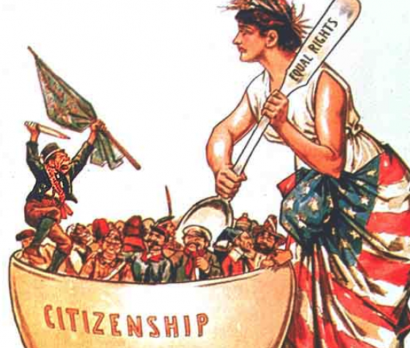
- What two immigrant groups worked on the Transcontinental Railroad?

- What types of problems did immigrants face upon entering the U.S. (as seen in the sign to the right)?

- How does the picture illustrate assimilation of immigrants?

- Which immigrant group was the first to be restricted from coming to the U.S.?
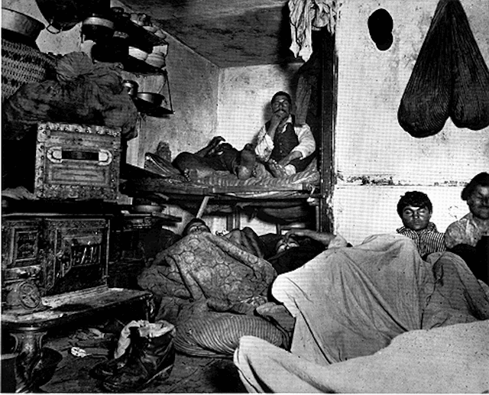

- Which city was the first to develop a subway system?

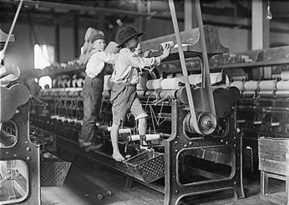
- What type of housing is seen to the right? Why were the cities so overcrowded?

- What other problems resulted from industrialization?

- What organizations were created to protest labor issues?

- What were the goals of the labor movement?

- “ _____________________” of segregation laws are depicted in this photograph. The U.S. Supreme Court upheld these laws in the _________________v. _______________________ case which established the principle of “__________________ but _____________.”
Matching: Match the people with the correct inventions / contributions.

- _______ Thomas Edison A. Believed in the importance of education and
- _______ Alexander Graham Bell obtaining equal rights; helped found NAACP
- _______ Wright Brothers B. Assembly line
- _______ Henry Ford C. Light bulb / electricity
- _______ Andrew Carnegie D. Oil
- _______ John D. Rockefeller E. Railroads
- _______ J.P. Morgan F. Anti-lynching crusade
- _______ Cornelius Vanderbilt G. Way to equality through vocational skills
- _______ Ida B. Wells H. Telephone
- _______ Booker T. Washington I. Airplane
- _______ W.E.B. DuBois J. Finance / banking
K. Steel
Fill-in-the-blank:
The Progressive Movement reforms include Theodore Roosevelt’s “_________________ Deal” and Woodrow Wilson’s “New ___________________.” The Progressive Movement was a response to the excesses of the _________________ Age which led to poor working conditions, low wages, child labor, and _______________ towns. Journalist called _________________________ exposed a lot of this time period’s problems. People wanted more input in their government which led to the _________ Amendment (allowing for the people to elect ______________), initiative (where votes can initiate a bill), ________________________ (where voters vote directly on a piece of legislation), and ____________ (where voters can remove an elective official). The two anti-trust laws to prevent the creation of _______________________ and price fixing were the _______________________ Anti-trust Act and the _____________________ Anti-trust Act. The Women’s Suffrage Movement also worked to get the _________ Amendment passed allowing women to vote.
Answer the following questions. Some are related to the images seen to the right.
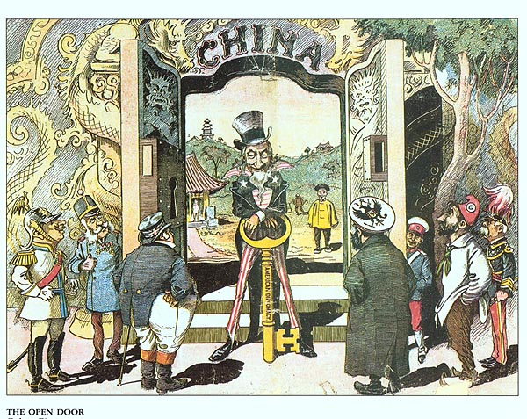
- The Open _______________ Policy proposed by Secretary of State John _____________ would give all nations equal trading right to the country of _______________.
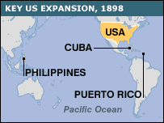
- As part of ____________________Diplomacy, Pres. Taft urged American businesses to invest in Latin America. He promised the U.S. would step in if unrest threatened their investments.
- The territories to the right were annexed by the U.S. after the _____________________________ _________________________ War.
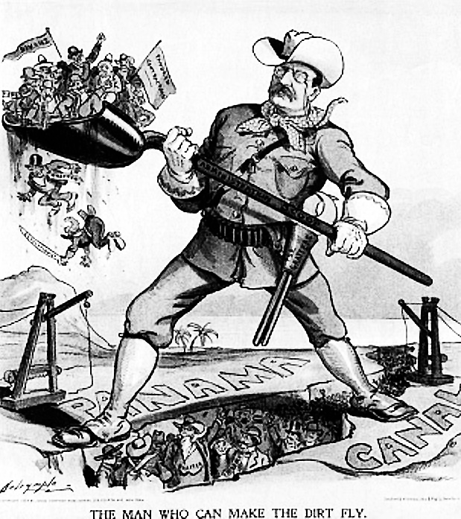
- Pres. ____________________________________ encouraged Panama’s independence from Colombia in order to negotiate the building of the _______________________ which connects the Atlantic and Pacific Oceans.
- How does the political cartoon below illustrate the causes of World War I? (hint: MAIN)

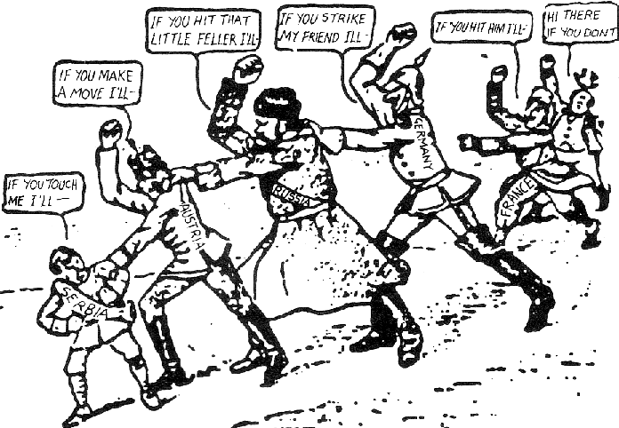
- What event sparked WWI?

- What countries were the Central Powers?

- What countries were the Allied Powers?
- For three years, America remained ________________. The decision to enter the war was the result of continuing German ________________________warfare (sinking of the _______________________) and American ties to Great Britain.
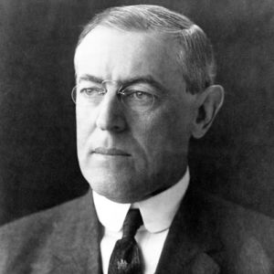
- Pictured to the right is ________________________________ who said Americans should “make the world ____________for ___________________________.”
- Wilson’s Plan to eliminate the causes of war was caused the ____________________ Points. Key points of this plan included self-determination, freedom of the ___________, and the __________________ of ________________.
- Which country was required to pay reparations as punishment for the war?
- Did the U.S. Senate approve the Treaty of Versailles?
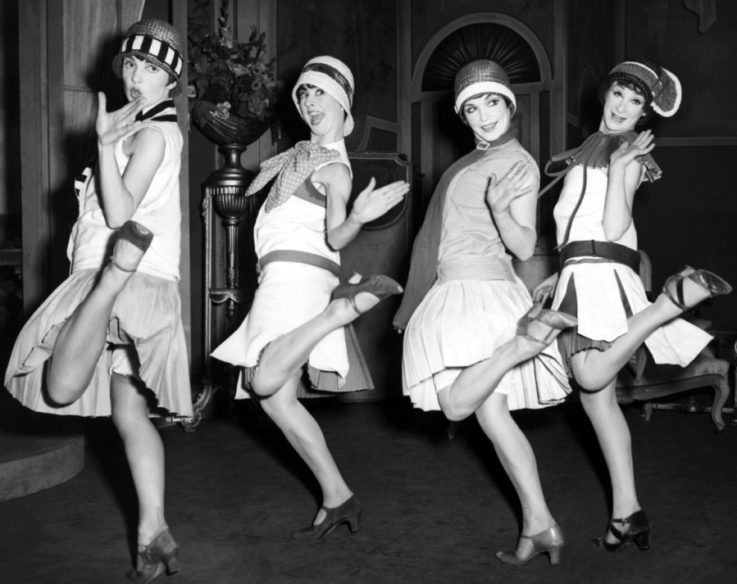
- In the 1920s and 1930s, mass media and communications increased through the __________ which broadcasted ___________ music and Pres. Franklin D. Roosevelt’s _________________ chats. Movies provided escape from Depression-era realities. There were challenges to traditional values and religion including Darwin’s Theory of ______________________ which was an issue at the ____________ Trial
- How did traditional women’s roles change in this era?

- What law led to the smuggling alcohol and speakeasies?

Graphic Organizer: Complete the information below.

Fill-in-the-blank:
Pres. Franklin Roosevelt’s __________ ______________ Program changed the role of the government to a more active participant in solving problems. Roosevelt rallied a frightened nation in which one in four workers was______________________. (“We have nothing to ___________, but fear itself.”) Relief measures provided direct payment to people for immediate help (Works ______________ Administration—WPA). Recovery programs were designed to bring the nation out of the depression over time (Agricultural Adjustment Administration—AAA). Reform measures corrected banking and investment practices (Federal _______________ Insurance Corporation—FDIC). Social _________________ Act offered safeguards for workers. The legacy of the New Deal influenced the public’s belief in the responsibility of government to deliver public services, to intervene in the economy, and to act in ways that promote the general welfare.
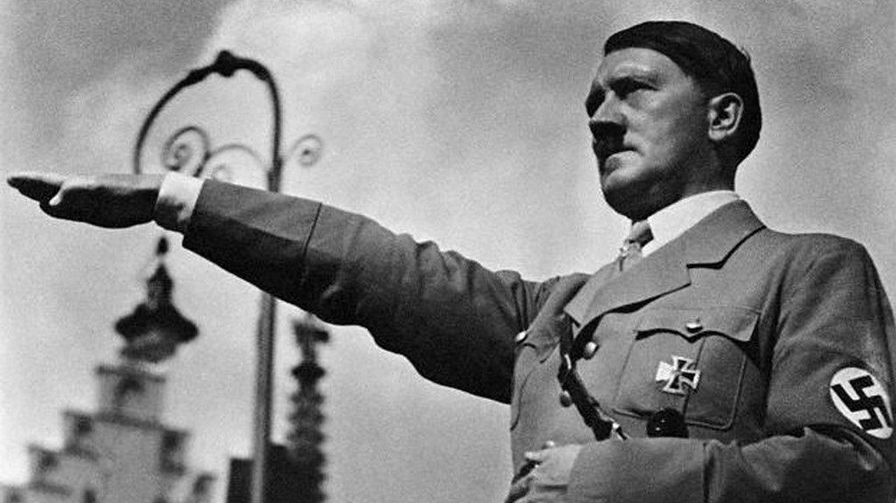
Answer the following questions. Some are related to the images seen to the right.
- Who is pictured to the right? What country did he lead and what did he do that started WWII?

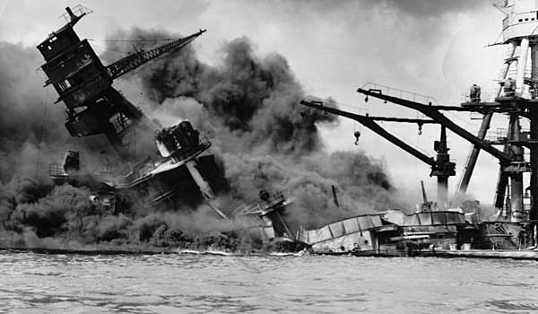
- During the first two years of the war, the U.S. stayed officially ________________ while _____________overran France and most of Europe and pounded Britain from the air (the Battle of Britain). In mid-1941, Hitler turned on his former partner and invaded the __________ ________________.
- Before officially entering WWII, how did the U.S. help Britain? What FDR quote helps describe this program?

- What attack, pictured to the right, led to a U.S. declaration of war against Japan? What FDR quote describes this date in history?

- Allied strategy during WWII focused on defeating ______________ first. The strategy in the Pacific was called __________________________________.
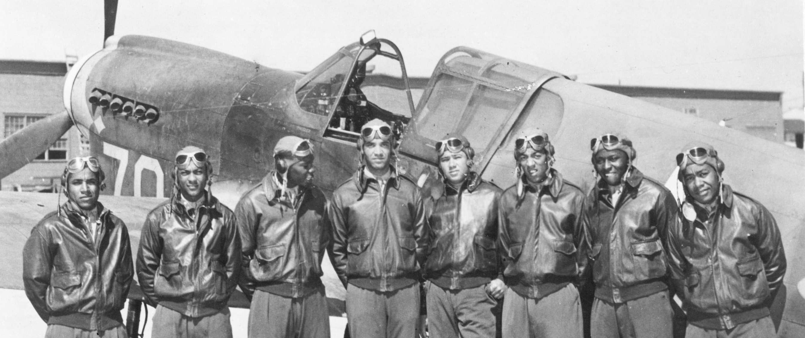
- What African American unit served with distinction in WWII?

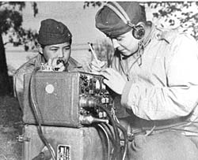
- What minority group is seen here? What important contribution did they make during WWII?

- The _______________ Regiments were made up of Japanese Americans and were highly decorated. Ironically, there was strong anti-Japanese ______________________, and many Japanese Americans were relocated to _________________________camps.
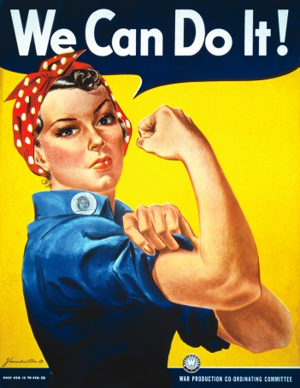
- What does the poster to the right illustrate about the home front during WWII?

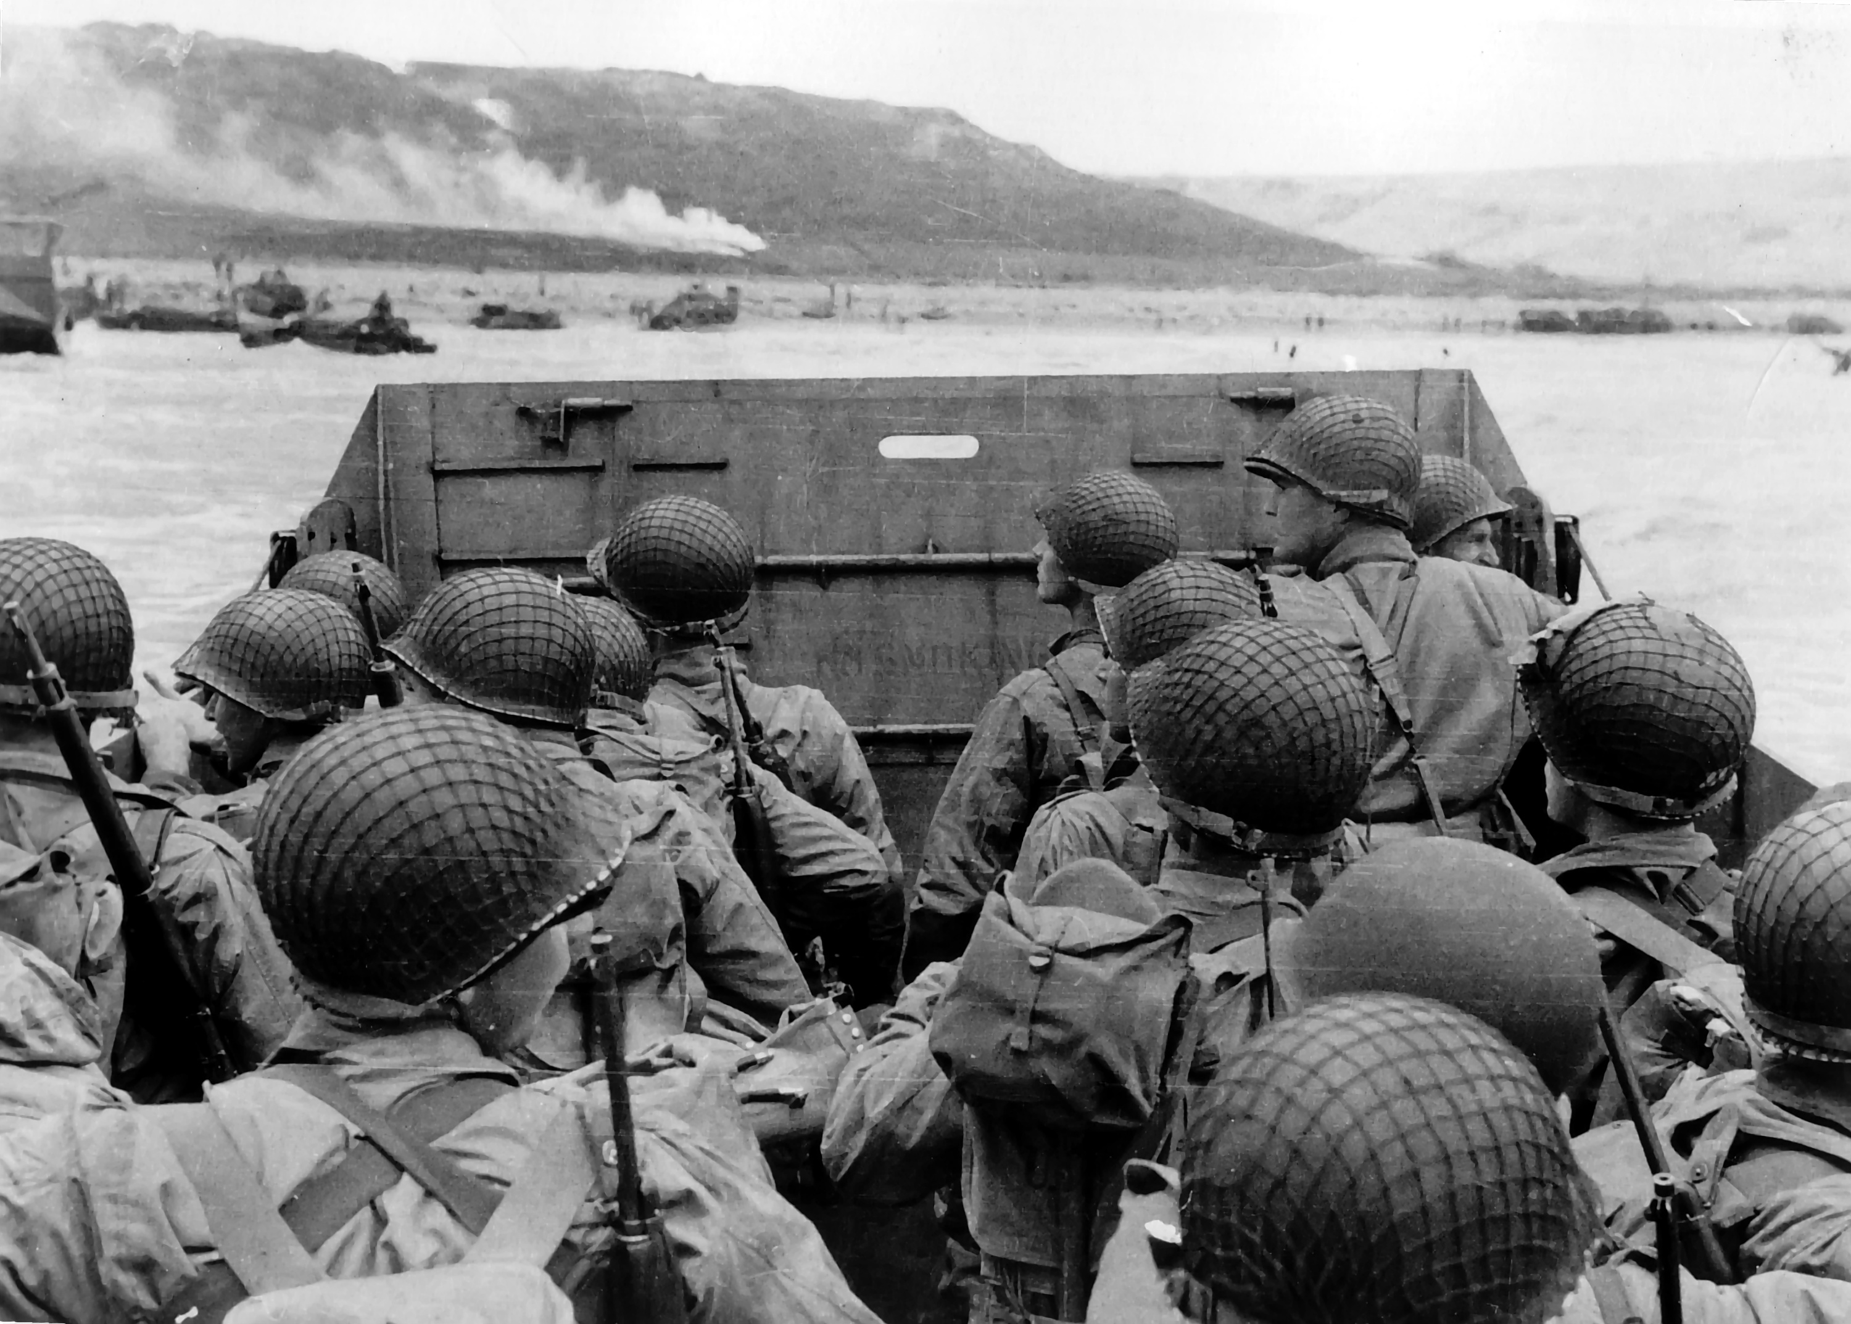
- Major battles and military turning points include the Battle of _______________ in North Africa which prevented Hitler from gaining access to Middle Eastern __________ supplies. The German defeat at the Battle of _________________ prevented Germany from seizing the Soviet ________ fields and turned the tide against Germany in the east.
- The picture to the right illustrates the “___________” landings at ____________________, France on June 6, 1944 which started the Allied liberation of Europe from Nazi control.
- The turning point in the Pacific was the Battle of _____________. The Battles of _________________ and ___________________ costs many American and Japanese lives as many Japanese soldiers would rather commit ______________ than surrender. This convinced President ________________________ to use the _________________________ against Japan at the cities of ________________________ and __________________.
- The _____________________ Convention tried to ensure humane treatments of prisoners of war (POWs); the __________________ Death March during WWII highlighted the brutal treatment of American POWs by the __________________________.
- The systematic and purposeful destruction of a racial, political, religious, or cultural group is called _____________________. Nazi Germany started the “Final Solution” which tried to exterminate all ____________. Other groups were also affected including Poles, Slaves, Gypsies, and undesirables.
In the ________________________ trials, Nazi leaders and others were convicted of war crimes. The trials led to increased demand for a ________________ homeland.
Chart: Complete the information below.
United States after WWII | Soviet Union after WWII
- Represented _________________________ ideals and political institutions  - Member of __________________ a military alliance to prevent a Soviet invasion of Western Europe  - Occupied ________________ Germany  - Occupied the country of ________________ which adopted a democratic form of government and became a strong ally  - Rebuilt Western Europe using the ______________________ Plan  - Used the ___________________ Doctrine to _____________ communism  - Used Eisenshower’s Policy of _____________________ Retaliation to deter the Soviets | - Represented _______________________ ideals  - Created the ____________________________ which was a military alliance in Eastern Europe  - Occupied most of _________________ Europe and the _________________ portion of Germany
Answer the following questions. Some are related to the images seen to the right.
- U.S. involvement in the Korean War in the early 1950s reflected the American policy of ____________________ of communism. It eventually ended in a stalemate with North Korea remaining _____________________ and South Korea remaining ______________________.
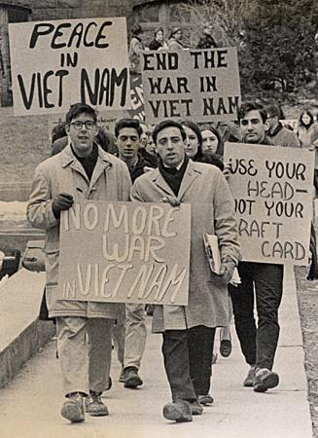
- After the assassination of Pres. _______________________ in Nov. 1963, U.S. military buildup in Vietnam intensified under Pres. _________________________________.
- What is illustrated by the picture to the right?

- Pres. Nixon institution a policy of “__________________________”, withdrawing U.S. troops and replacing them with South Vietnamese forces while maintaining military aid to the South Vietnamese. Nixon was forced out of office by the ______________________ Scandal. In 1975, North and South Vietnam were merged under ____________________ control. Vietnam veterans were treated very ________________ when they returned home.
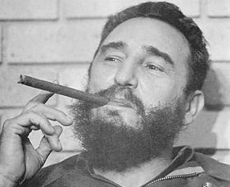
- Who is the communist leader pictured here who took control over Cuba in the late 1950s?

- What was the failed invasion of Cuba in 1961 called?

- In 1962, the ________________________ stationed missiles in Cuba, instigating the ______________________________________. President Kennedy ordered the Soviets to remove their missiles, and for several days the world was on the brink of _________________ war. Eventually, the Soviet leadership “_______________” and removed their missiles.
- What was “McCarthyism?”

- Why did heavy military expenditures throughout the Cold War benefit Virginia more than other states?

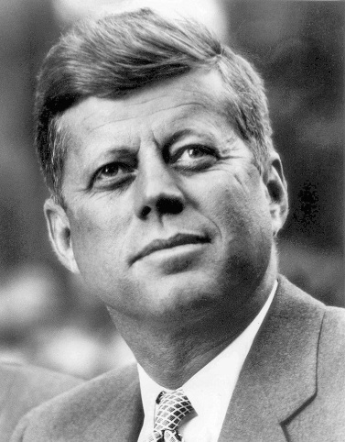
- Who said the quotations below?
“We will pay any __________, bear any burden, meet any hardship, support any____________, oppose any _________, in order to assure the survival and the success of liberty…”
“Ask not what your _______________can do for you; ask what you can do for your country.”

- Who said the quotation below?
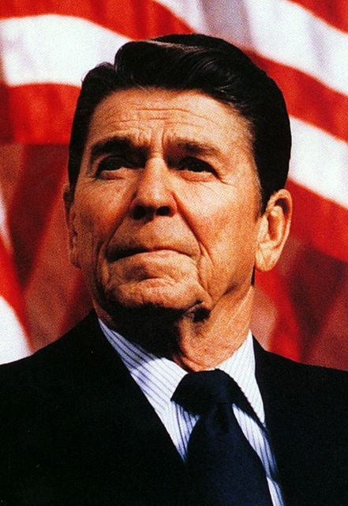

“Mr. Gorbachev, tear down this ____________!”

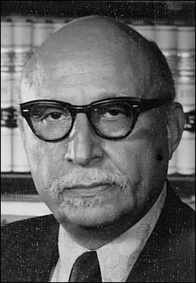
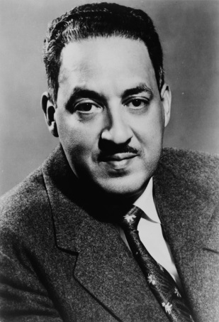
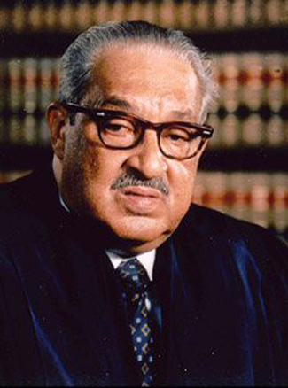
- Increasing Soviet ____________________ expenses to compete with the U.S., rising nationalism in Soviet republics economic inefficiency, and ______________________’s policies of glasnost and perestroika (openness and economic restructuring) led to the fall of the ________________________ in 1991.
- _____________________ v. ________ ______________________________ was the Supreme Court decision that segregated schools are unequal and must desegregate. This Virginia NAACP attorney named ___________________ helped argue the Prince Edward case which was included in the Brown case. This NAACP attorney named ____________________________ argued the Brown case before the Supreme Court and eventually become a ______________________________.
- How did Virginia respond to integration (3 things)?

- What civil rights organization challenged segregation through the court system?
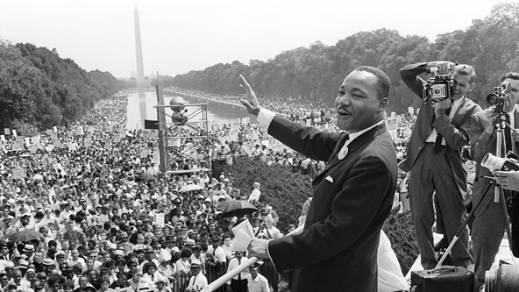
- What event is pictured to the right? What famous speech was made there?

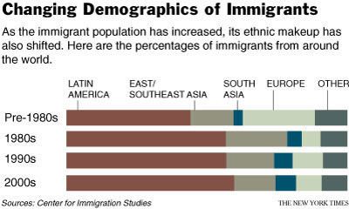
- What does the graphic to the right illustrate concerning current immigration patterns?

Matching: Match each with the correct description.
- _______ Civil Rights Act of 1964
- _______ Voting Rights Act of 1965
- _______ Sandra Day O’Connor, Ruth Bader Ginsburg, Clarence Thomas
- _______ John Glenn
- _______ Neil Armstrong
- _______ Sally Ride
- _______ GPS, satellite technology, cell phones, robotics
- _______ Telecommuting
- _______ Outsourcing & offshoring
- _______ Conservative “Reagan Revolution”
- _______ Patriot Act
- _______ Federal Reserve
- 1st female American astronaut.
- The advent of new technologies including the Internet have allowed people to do this which means to work from a home office or other location.
- Makes monetary policy decisions to control the supply of money and credit to expand or contract economic growth.
- 1st American to orbit Earth.
- Prohibited discrimination based on race, color, religion, gender, or national origin & desegregated public accommodations.
- Examples of technological advances made as a result of NASA technologies.
- Movement focused on tax cuts, reduction in the number of government programs and regulations, and strengthening of the American military. Included Presidents George H.W. Bush, William Clinton (even though he was a Democrat), and George W. Bush.
- Sending companies and job opportunities to foreign countries to cut back on costs.
- 1st person on moon; “That’s one small step for a man; one giant leap for mankind.”
- Illustrates the inclusion of women and minorities onto the Supreme Court.
- Outlawed literacy tests and resulted in an increase in African American voters.
- As a response to terrorism, the U.S. increased security measures at home.

