VA/US History SOL Review Packet: Part I

Name: ____________________________________ SOL Test Date: __________________________
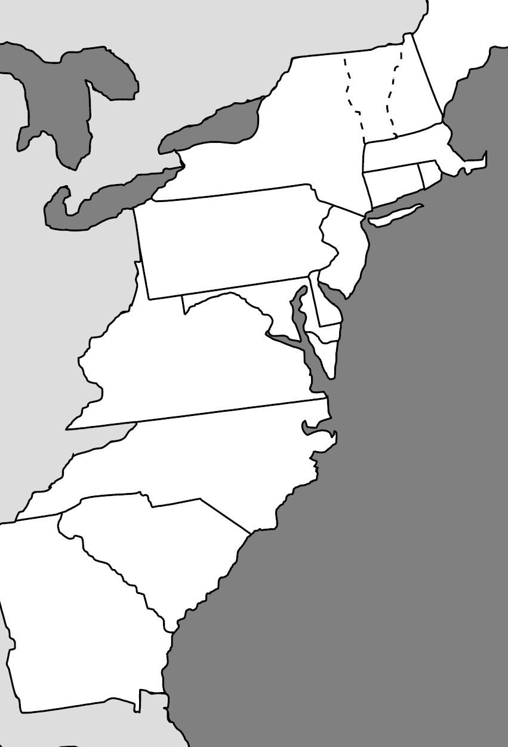
Map: Label the 13 colonies.
- New Hampshire
- Massachusetts
- Connecticut
- Rhode Island
- New York
- New Jersey
- Pennsylvania
- Delaware
- Maryland
- Virginia
- North Carolina
- South Carolina
- Georgia

Matching: Match the following descriptions under the correct colonial region.
- Joint-stock Company
- Religious toleration with flexible social structure (had middle class)
- “Covenant community”
- English, Dutch, & German speaking immigrants
- Town meetings (form of “Athenian” direct democracy)
- Puritans
- Mayflower Compact
- English nobility received land grants “Cavaliers”
- Strong belief in hard work and thrift
- Intolerance of other religious beliefs
- “Cash crops”
- Shipbuilding, fishing, lumbering, small-scale subsistence farming
- Large plantations

New England Colonies Middle Colonies Southern Colonies

Fill-in-the-blank:
Thomas Paine was an English immigrant to America who produced a pamphlet known as _______________________________ that challenged the rule of the American colonies by the King of England. Common Sense was read and acclaimed by many American colonists during the mid-1700s and contributed to a growing sentiment for independence. The eventual draft of the Declaration of Independence, authored by _____________________________ of Virginia, reflected the ideas of _______________ and Paine. Jefferson wrote: “We hold these truths to be self-evident, that all men are created ___________________, that they are endowed by their Creator with certain unalienable Rights, that among these are Life, ________________, and the pursuit of Happiness… That to secure these rights, Governments are instituted among Men, deriving their just powers from the ________________ of the governed… That whenever any Form of Government becomes destructive of these ends, it is the Right of the People to alter or __________________ it, and to institute new Government….”
Matching: Match each under the correct category of colonist.
- Remained loyal to Britain because of cultural & economic ties
- “Give me liberty, or give me death!”
- Believed in complete independence from Britain
- Tried to stay as uninvolved in the war as possible
- Inspired by the ideas of Locke and Paine
- Provided the troops for the American Army, led by George Washington
- Believed taxation was justified to pay for British troops to protect American settlers from Indian attacks
Patriots Loyalists Neutrals

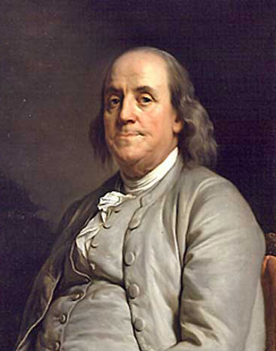
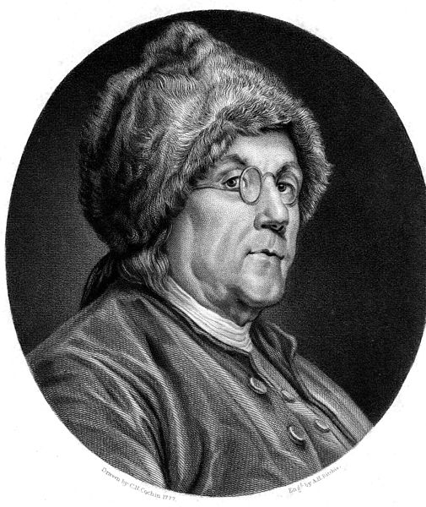

Fill-in-the-blank: The man pictured to the left is _________________________________ who negotiated a _________________________________ with the country of ______________. This treaty benefited the Americans at the Battle of ________________________ which ended the war with an American victory. American political leaders, fearful of a powerful ____________________ government like Britain’s, created the Articles of _______________________________, adopted at the end of the war.
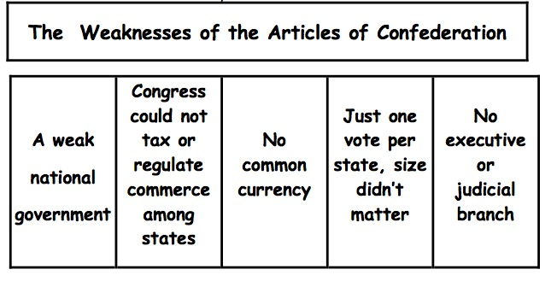

The new U.S. Constitution made federal law the __________________ law of the land. The _______________ Compromise balanced power between large and small states by creating a _______________, where each state has _______ senators, and a House of Representatives, where membership is based on _______________________. It avoided a too-powerful central government by establishing_________ co-equal branches—legislative, executive, and judicial—with numerous checks and ________________________. It placated the Southern states by counting slaves as ____________________ of the population when determining representation in the United States House of Representatives.
Matching: Match each with the correct description.
- George Washington 1. _________ President at the Constitutional Convention.
- James Madison 2. _________ Wrote the Virginia Statute for Religious Freedom.
- George Mason 3. _________ Established judicial review.
- Thomas Jefferson 4. _________ “Father of the Constitution” and author of Virginia
- Anti-Federalists Plan and Bill of Rights.
- Federalists 5. _________ Wrote the Virginia Declaration of Rights.
- Marbury v. Madison 6. _________ Set forth doctrine of “implied powers.”
- McCulloch v. Maryland 7. _________ Feared an overly powerful central government
- Gibbons v. Ogden destructive of the rights of individuals.
8. _________ Broad national view of economic affairs, particularly interstate commerce.
9. _________ Advocated importance of a strong central government, especially to promote economic development.
Chart: Fill in the missing parts of the chart.

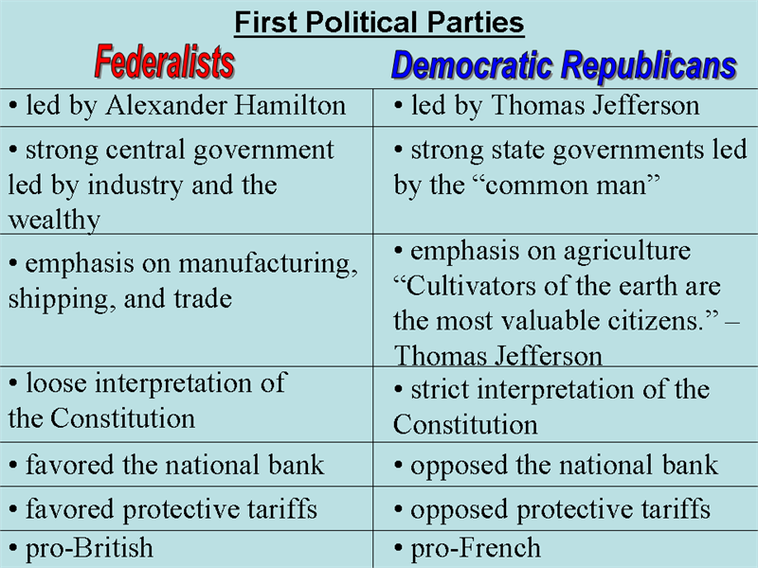

Fill-in-the-blank: The presidential election of _____________, won by Thomas ____________________, was the first American presidential election in which power was peacefully transferred from one _______________________________ to another.
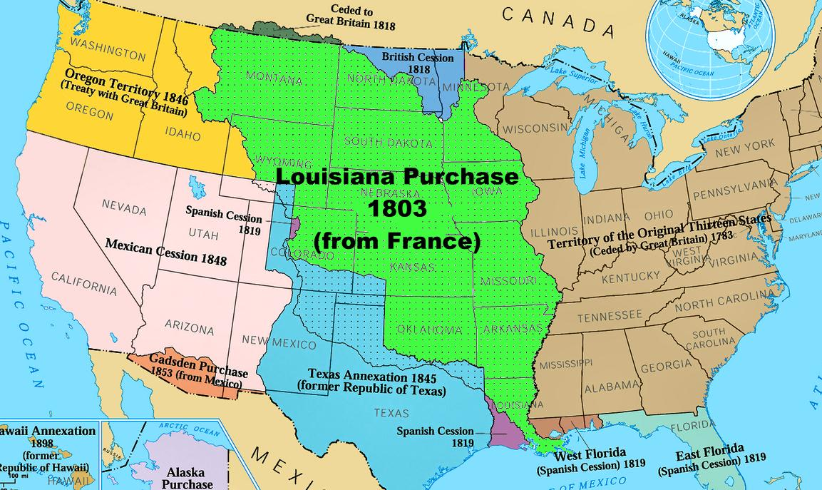
Map: Fill in the missing information on the map below.

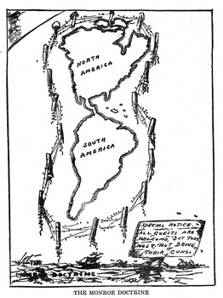
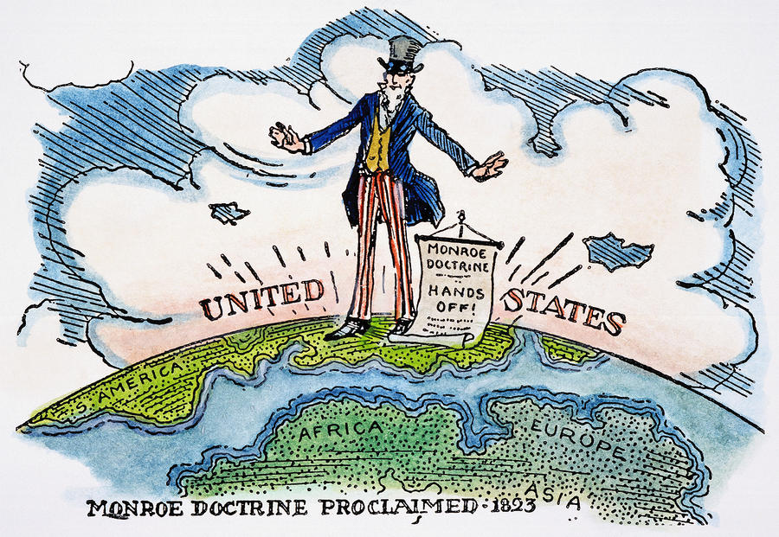
Political Cartoons: Answer the questions related to the illustrations.
- What U.S. foreign policy doctrine is illustrated by the political cartoons above?
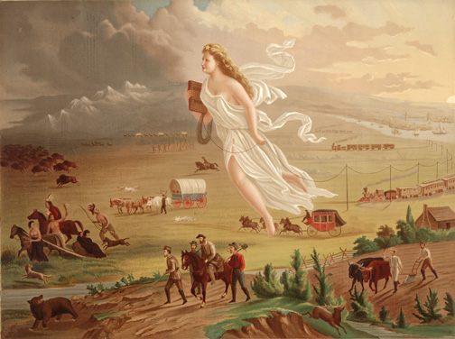
- According to this policy, the ________________ continents should not be considered for future ____________________________ by any ____________________________ powers.
- What is the primary message of the above political cartoons?

- What American belief is illustrated by the picture to the right?

- How did this belief affect American Indians?

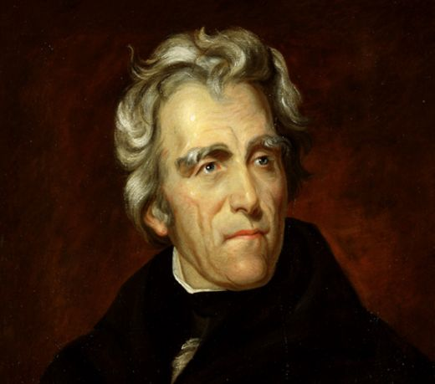
Fill-in-the-blank: The changing character of American politics in “the age of the __________________ man” was characterized by heightened emphasis on equality in the political process for adult white males, the rise of interest group politics and sectional issues, a changing style of campaigning, increased______________ participation. ____________________________ personified the “_______________________ spirit” of the age by challenging the economic elite and rewarding campaign supporters with public office (______________System). The Federalist Party disappeared, and new political parties, the Whigs and Know-Nothings, were organized in opposition to the _________________________ Party.

Slavery
Tariffs
Chart: Fill in the missing parts of the chart.

+ Agriculture in the South was based on ____________ labor
+ Northern abolitionist _______________________________ published the newspaper The Liberator which stated slavery was a violation of __________________ principles
+ Harriet Beecher Stowe wrote _________________________, a work of fiction that exposed the evils of slavery
+ North favored _____________ tariffs
+South ______________ tariffs
+ South Carolina argued they could ________________ the tariff of 1832 – “_______________________ Crisis”

Causes of the Civil War / Events Leading to the Conflict
Sectional Tensions Caused by Westward Expansion
Lincoln
+ After ___________________’s election as President, the state of _____________________________ secedes from the Union
+ The __________________________ Party was created the oppose the extension of slavery
+ Opening confrontation of war was at ________________________
+ Pres. Lincoln then called for troops to be raised against SC, this is when the state of __________________ seceded
+ Trying to maintain balance in Congress of “_________” & “__________” states as new states are added
+ Missouri Compromise – everything above line _________ in Louisiana Territory was to be free except for ________________ which was added as a slave state
+ Compromise of 1850 - ___________________ added as a free state
+ Kansas-Nebraska Act of 1854 – voters got to choose whether to be free or slave which is called ____________________________ and this led to the “Bloody ____________”

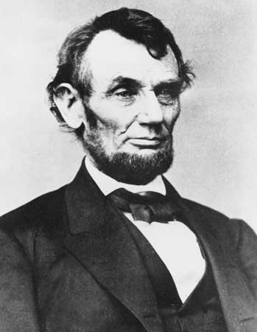
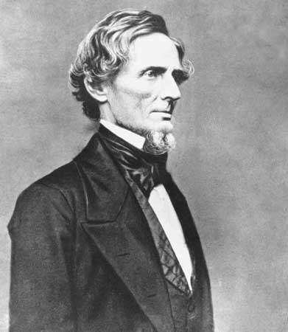
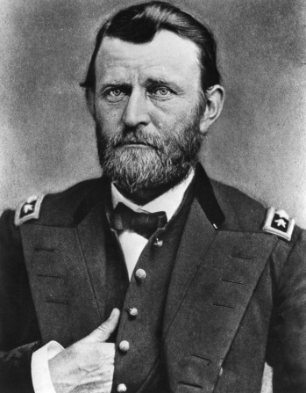
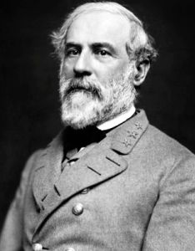
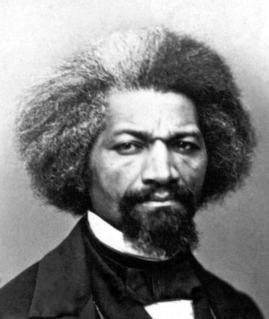
Matching: Match the correct information beside each key figure’s picture.
- Former slave who became prominent abolitionist
- President of the United States during the Civil War
- Union military commander
- U.S. senator who become President of the Confederate States of America
- Opposed secession, but did not believe the Union should be held together by force
- Urged Lincoln to recruit former enslaved African Americans to fight in the Union army
- Confederate General of the Army of Northern Virginia
- Made abolition of slavery a war aim by issuing the Emancipation Proclamation (which freed slaves in rebelling states).
- Urged Southerners to accept defeat and unite as Americans again
- His Reconstruction policy: “With malice towards none, with charity for all… to bind up the nation’s wounds….”
- Believed since secession was illegal, the states had never really left the Union
- Was elected President and served during most of Reconstruction
- Pres. of Washington College after the war (Washington & Lee University today); emphasized education
- Advocated for the passage of the 14th and 15th Amendments; served as ambassador to Haiti

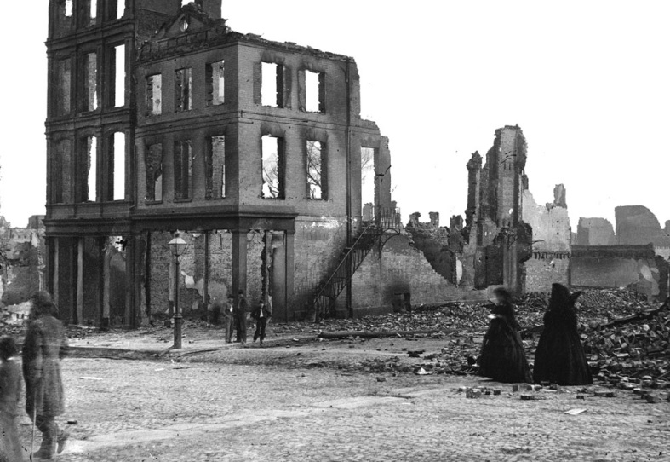
Fill-in-the-blank: The assassination of _____________________ just a few days after Lee’s surrender at ___________________________ enabled Radical Republicans to influence the process of Reconstruction in a punitive manner. The states that seceded were not allowed back into the Union immediately, but were put under ________________________occupation. Radical Republicans clashed with Lincoln’s successor as president, ______________________________, eventually impeaching him, but failing to remove him from office. Three “Civil War Amendments” to the Constitution were added: 13th Amendment: ______________________ was abolished. 14th Amendment: States were prohibited from denying ______________________ under the law to any American. 15th Amendment: _______________________ were guaranteed regardless of “race, color, or previous condition of servitude” (former slaves). The Reconstruction period ended following the close presidential election of 1876. In return for support from Southern Democrats in the Electoral College vote, Republicans agreed to end military occupation of the South. Known as the ______________________ of 1877, it opened the door to the “________________________ Era” and began a long period in which African Americans in the South were denied the full rights of American citizenship.
- How does the picture to the right illustrate the economic impact of the Civil War on the South?

- Why was the westward movement of settlers intensified after the Civil War?

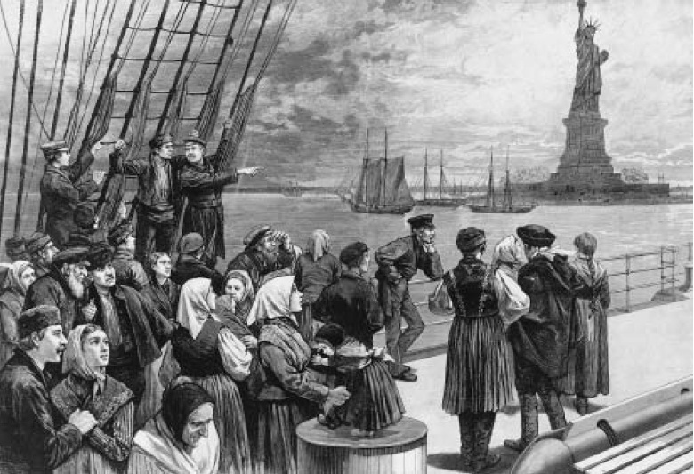
- What is illustrated by the cartoon to the left?

- What are push and pull factors? Give examples.

