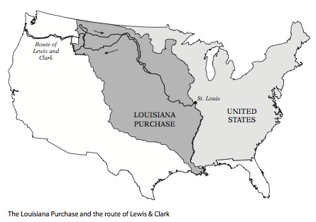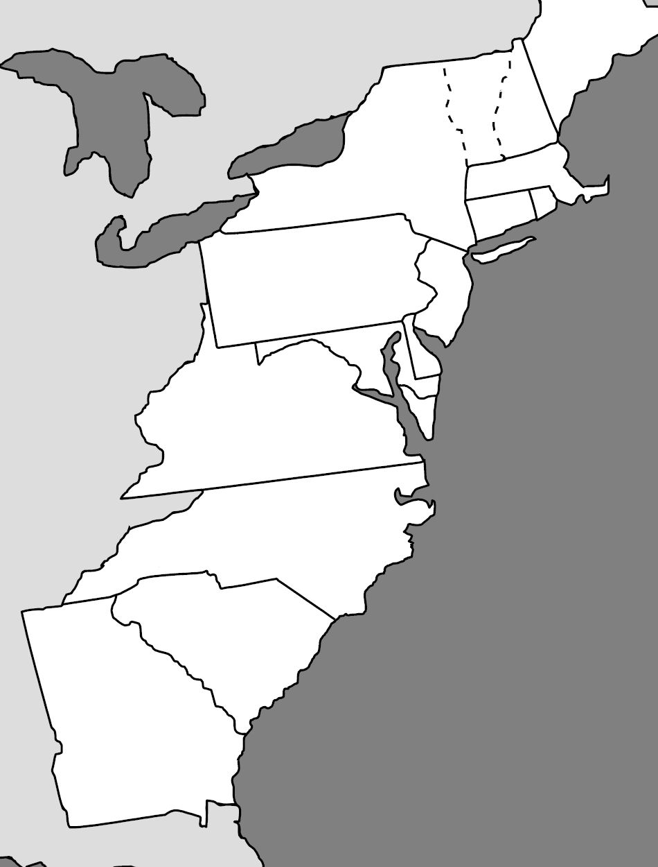**US History SOL Map Review Name: _________________________________**



The arrows and lines on the map above indicate –

1. the Proclamation Line of 1763.
2. the Ohio River Valley.
3. the route of Lewis and Clark.
4. the 1849 Gold Rush to California.

- Label the following:

* Massachusetts
* Virginia
* Rhode Island
* Pennsylvania

- Put a star beside Jamestown.

- Write Quakers inside the colony they established.

- Write Puritans inside the colony they established.

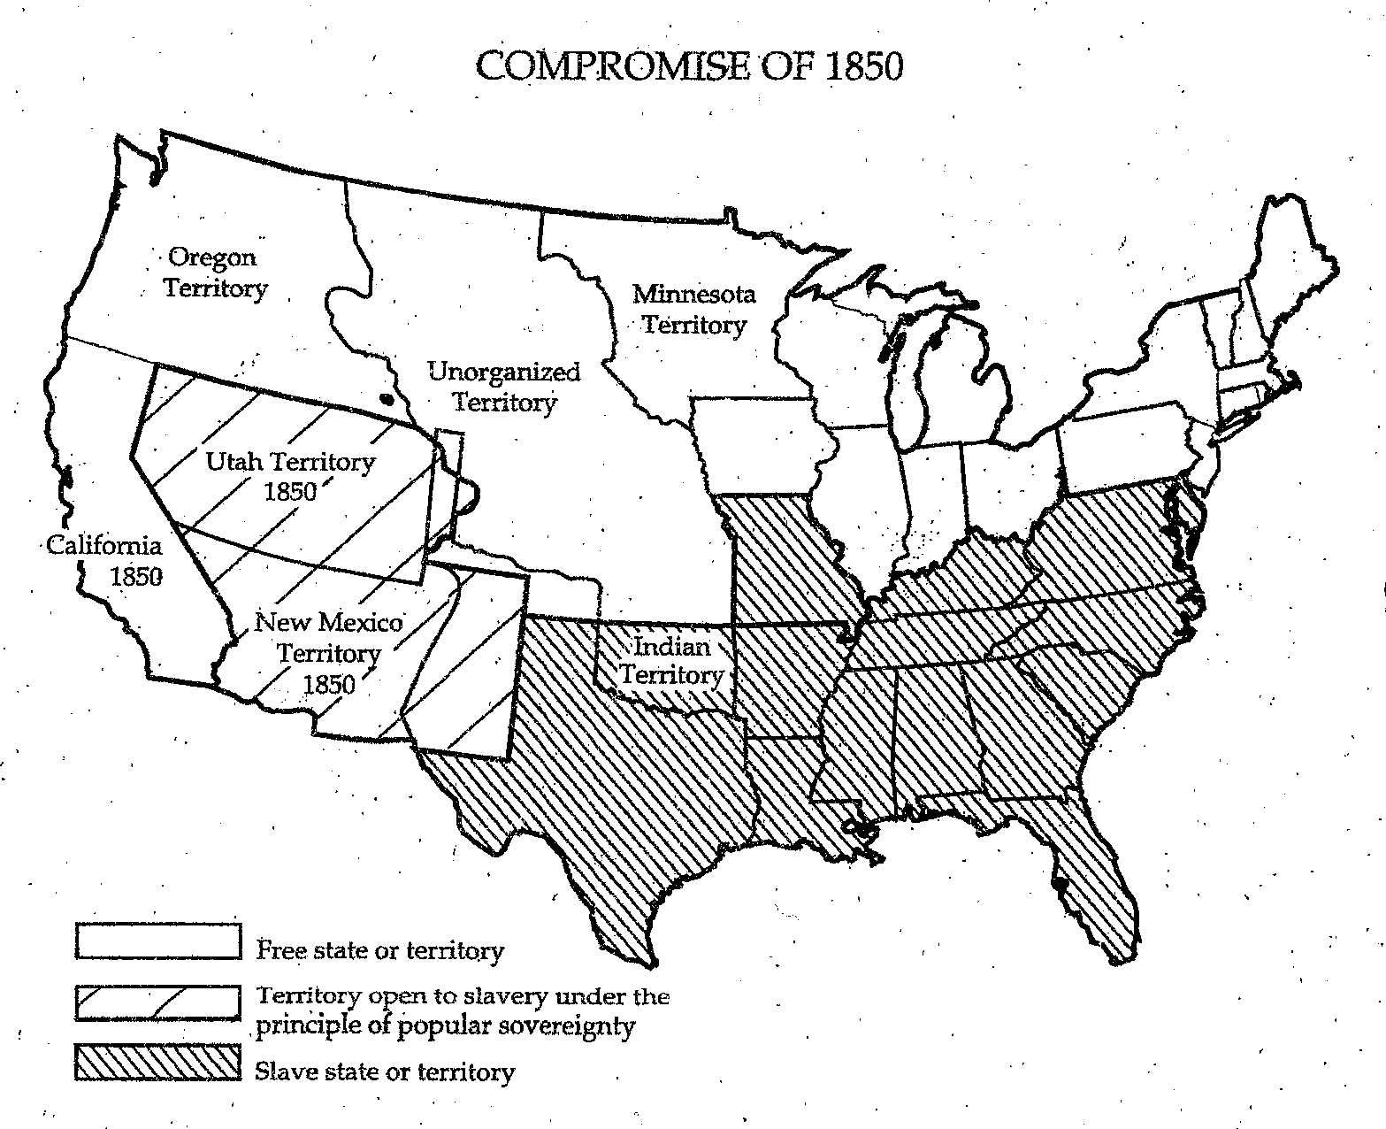

The title of the following map is –

1. Missouri Compromise.
2. Compromise of 1850.
3. Kansas-Nebraska Act of 1854.
4. 1849 Gold Rush to California.

Label Texas on the map.

Label Florida on the map.

Color in California on the map.

On the map, the white areas represent –

1. free states.
2. slaves states.
3. areas open to slavery under the principle of popular sovereignty.
4. unorganized territory.

On the map, the Utah and New Mexico territories are –

1. free states.
2. slaves states.
3. areas open to slavery under the principle of popular sovereignty.
4. unorganized territory.

Texas is a –

1. free state.
2. slave state.
3. popular sovereignty state.
4. Indian territory.

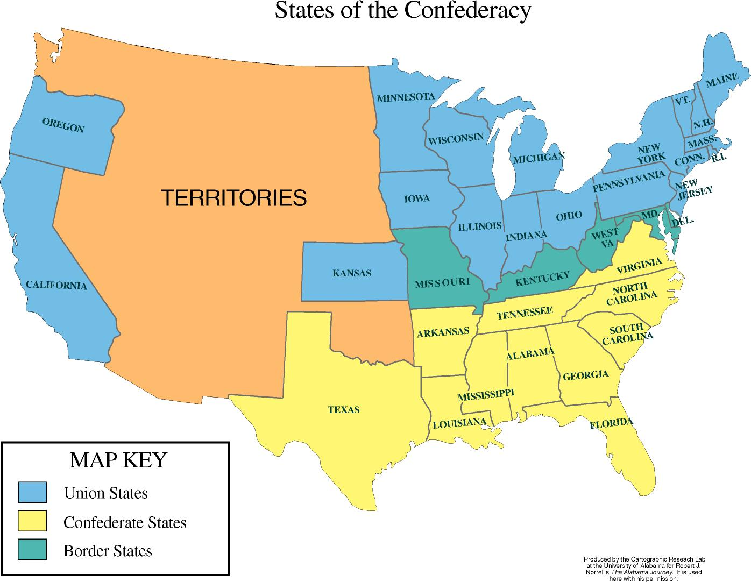

- Fill in the map key with the following –

* Confederate States
* Union States
* Border States

- Circle the state which seceded from the Union first.

- Put a star in the state where the Battle of Gettysburg occurred (which was the turning point of the Civil War).

- Put a star in the state where General Robert E. Lee surrendered the Confederate Army to General Ulysses S. Grant.

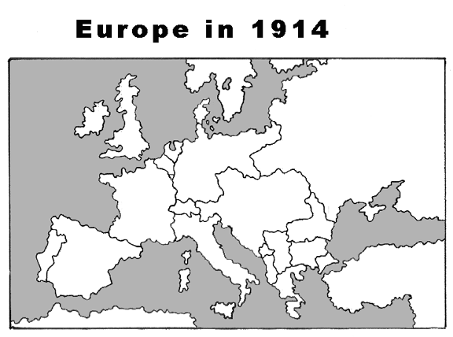

- Label the following:

* England
* France
* Italy
* Germany
* Austria-Hungary
* Serbia
* Ottoman Empire
* Russia

- Label the major Central Powers of Germany, Austria-Hungary, and the Ottoman Empire with CP under their names.

-Label the major Allied Powers of Great Britain, France, Italy, and Russia with AP under their names.

The assassination of Austrian Archduke Franz Ferdinand –

1. sparked WWI.
2. ended WWI.
3. led to WWII.
4. ended WWII.

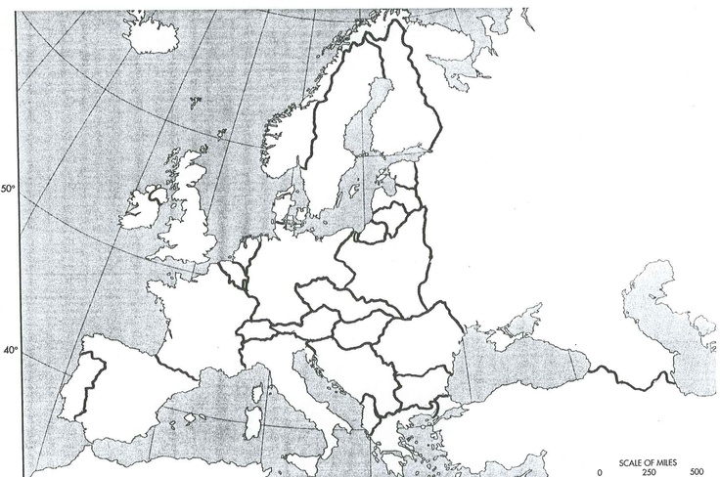**World War II**

- Label the following:

* England
* France
* Italy
* Germany
* Czechoslovakia
* Poland
* Soviet Union

- Label the major Axis Powers of Italy and Germany with Axis under their names.

-Label the major Allied Powers of Great Britain, France, and the Soviet Union with AP under their names.

World War II started with the –

1. assassination of Archduke Franz Ferdinand.
2. sinking of the Lusitania.
3. bombing of Pearl Harbor.
4. German invasion of Poland.

The small map at the bottom of this page most likely shows –

1. German invasion of Poland.
2. attack on Pearl Harbor.
3. Allied strategy of island hopping.
4. dropping of the atomic bomb.

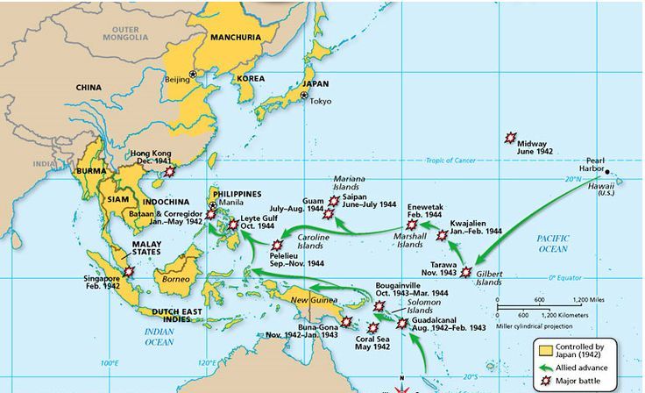

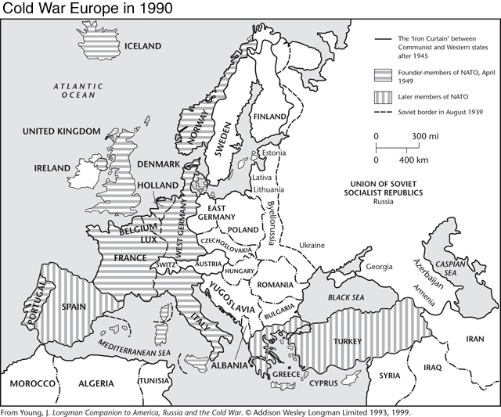

This map is most likely from what era?

1. WWI
2. WWII
3. Cold War
4. Vietnam War

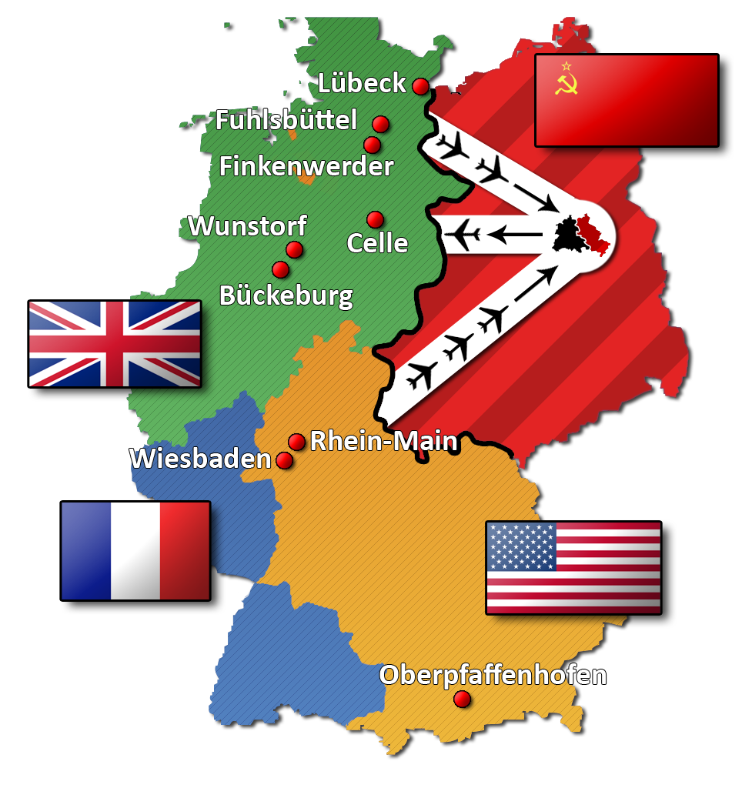

The graphic above most likely represents the –

1. Berlin War.
2. Berlin Airlift.
3. collapse of the Berlin War.
4. breakup of the Soviet Union.

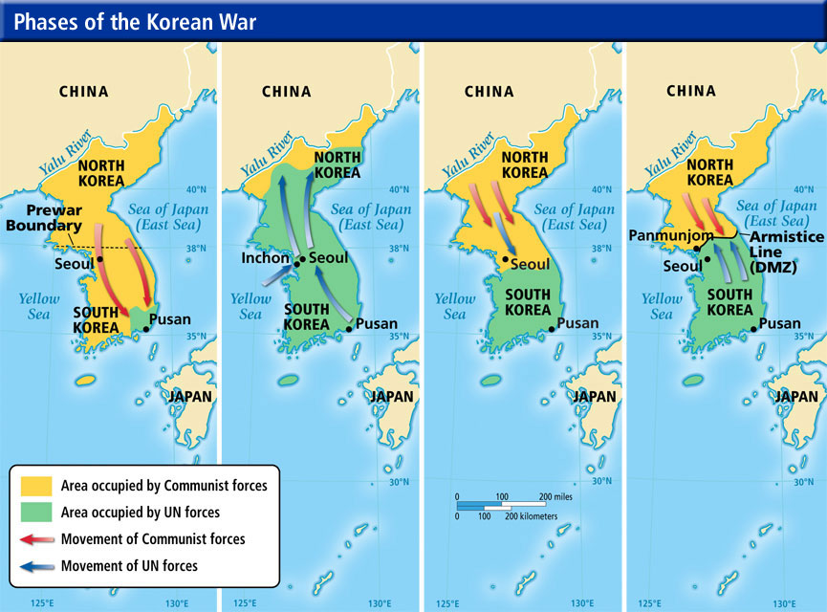

These two maps represent struggles against –

1. Soviet dominance of Europe.
2. Hitler’s aggression in Europe.
3. communism in Asia.
4. Japanese dominance in Asia.

Both wars reflect the American policy of –

1. deterrence.
2. massive retaliation.
3. containment.
4. isolationism.

The result of the Vietnam War was –

1. North and South Vietnam were merged under communist control.
2. a DMZ line was established separating North and South.
3. the Iron Curtain fell along the line of demarcation.
4. North and South Vietnam were merged under democratic control.

The picture seen below illustrates –

1. America’s division over the war and active opposition seen, especially on college campuses.
2. America’s support for Americanization of the war.
3. America’s support for Vietnamization.
4. America’s growing civil right movement.

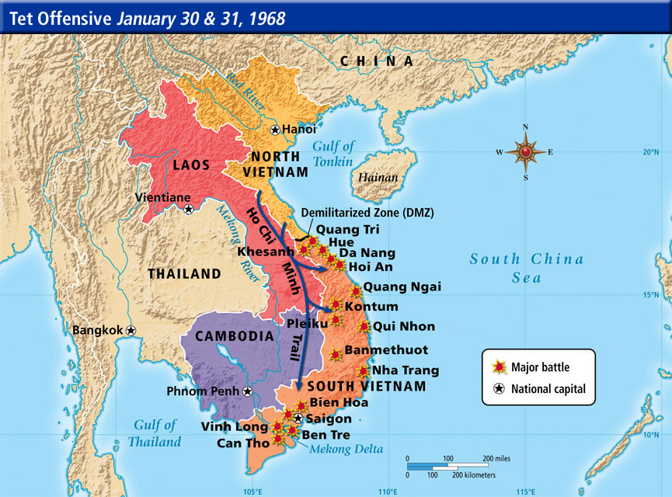

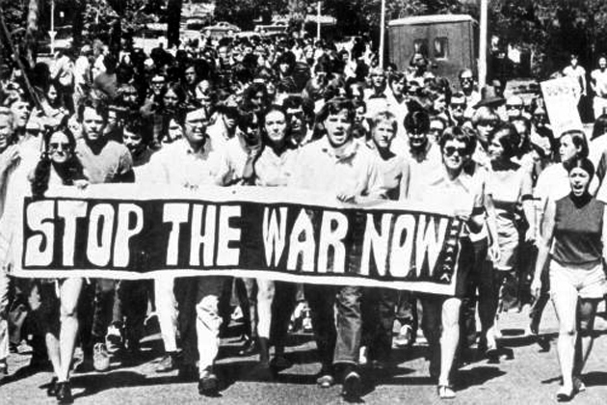

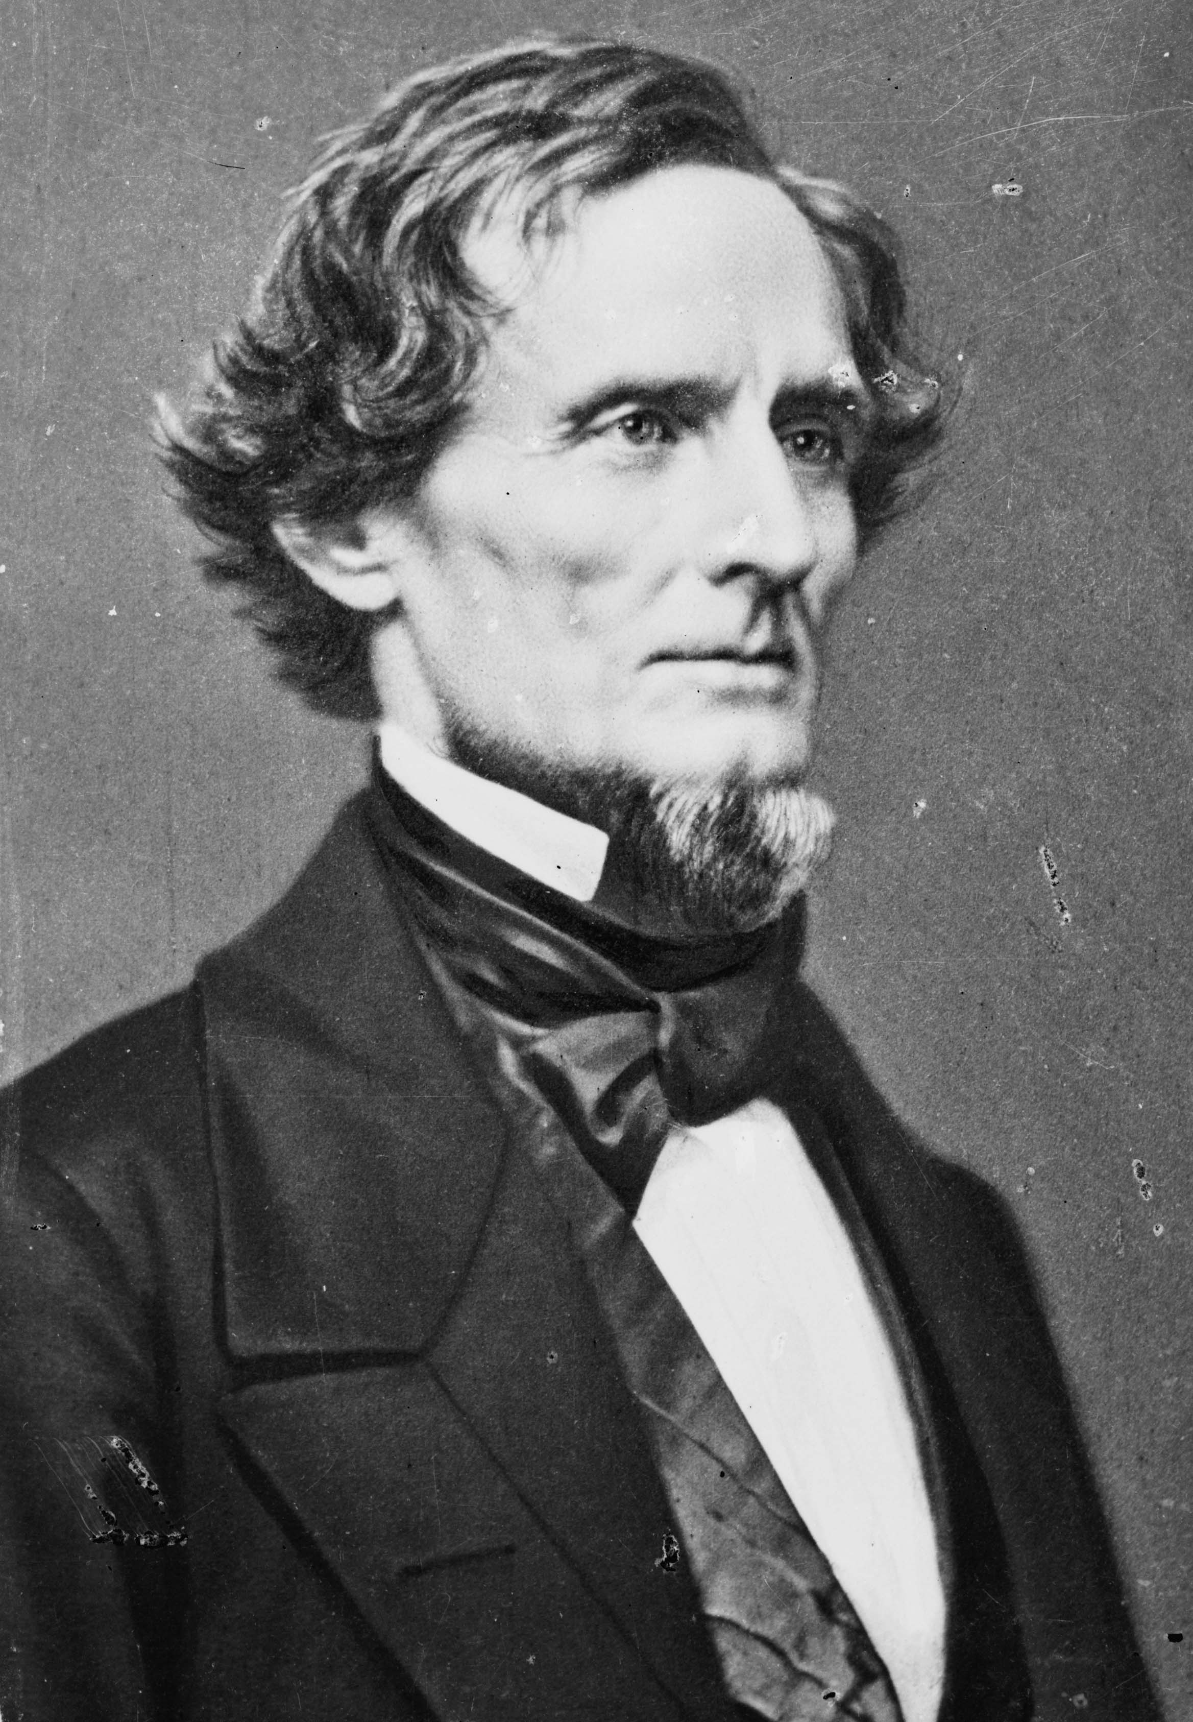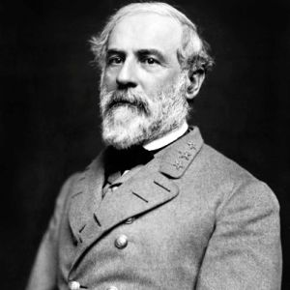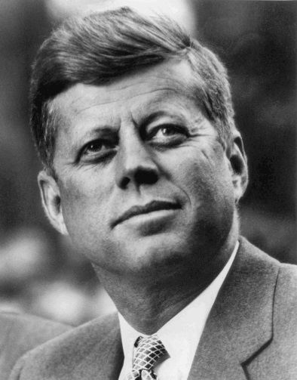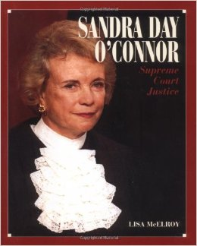**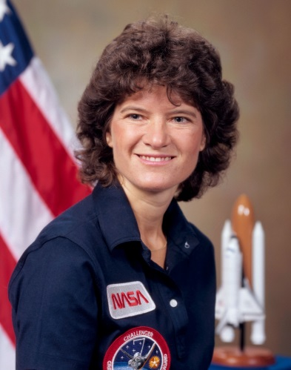US History People Review**

**5**

**4**

**3**

**2**

**1**

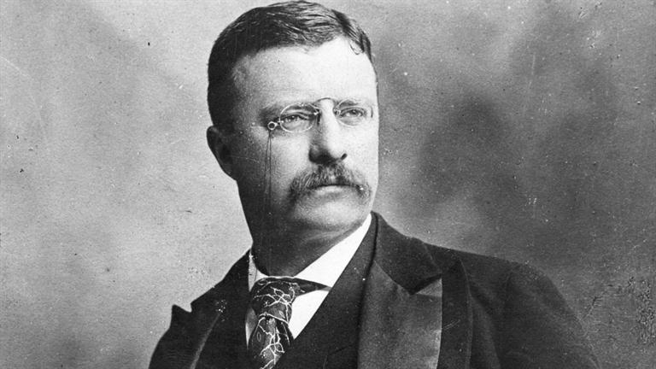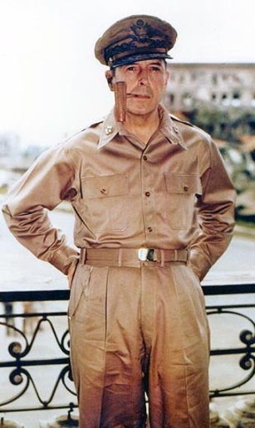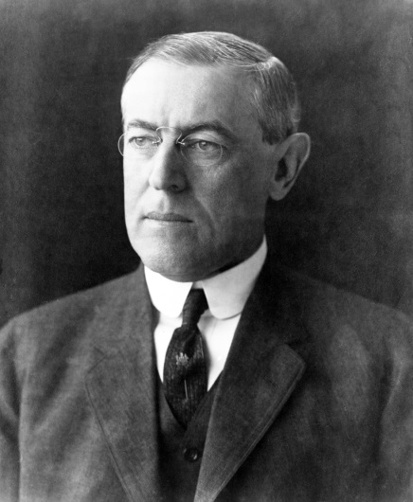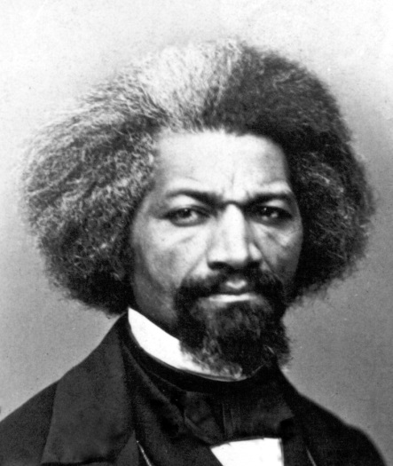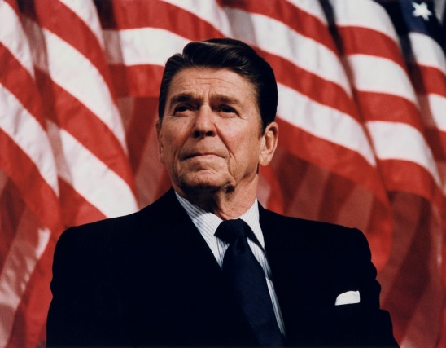

**6**

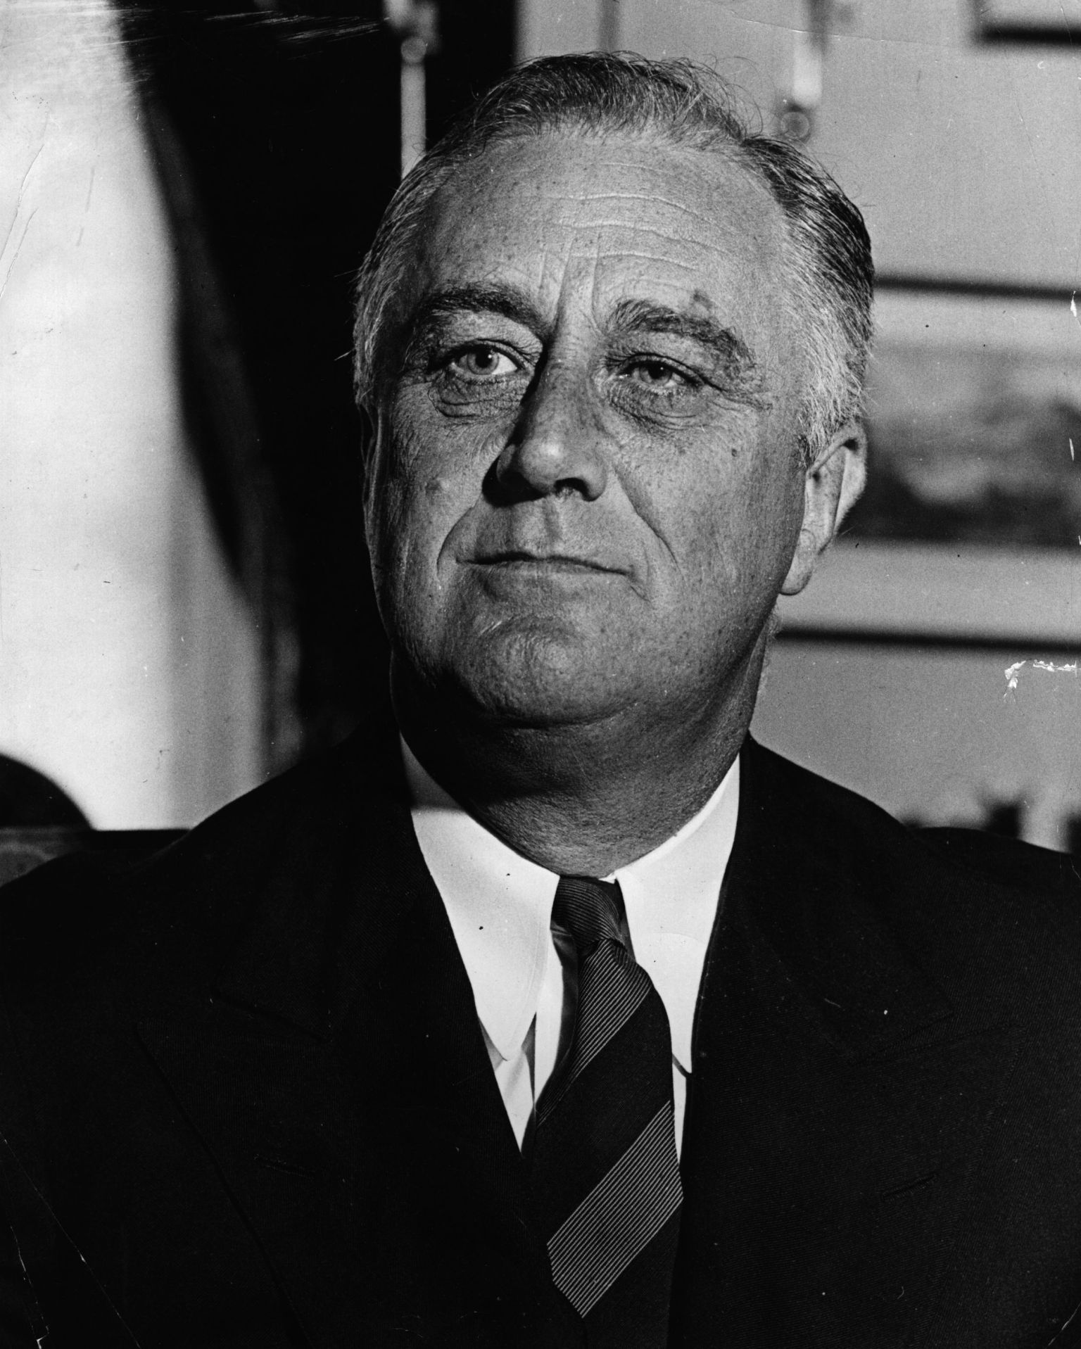

**10**

**9**

**8**

**7**

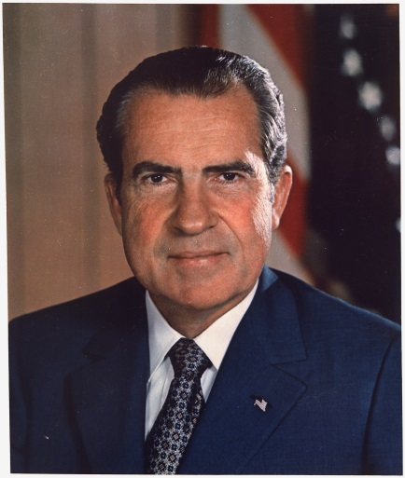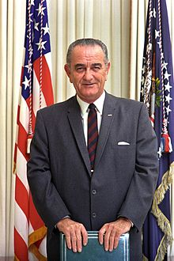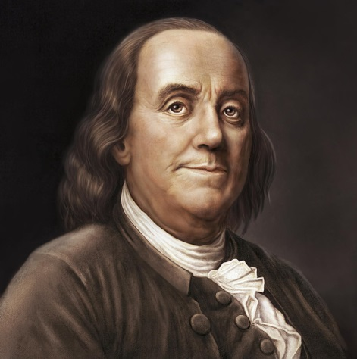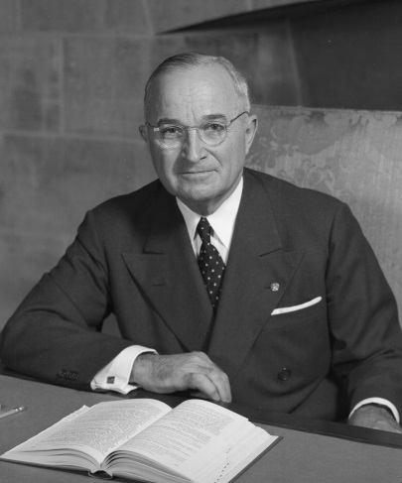

**15**

**14**

**13**

**12**

**11**