Egypt & Hebrews Study Guide

Map – Label the map below using your textbook.
- Label Lydia (Asia Minor)
- Label Phoenicia
- Label Israel & Judah
- Put a star where the holy city of Jerusalem is located
- Label Egypt
- Label the Sinai Peninsula
- Label the Red Sea
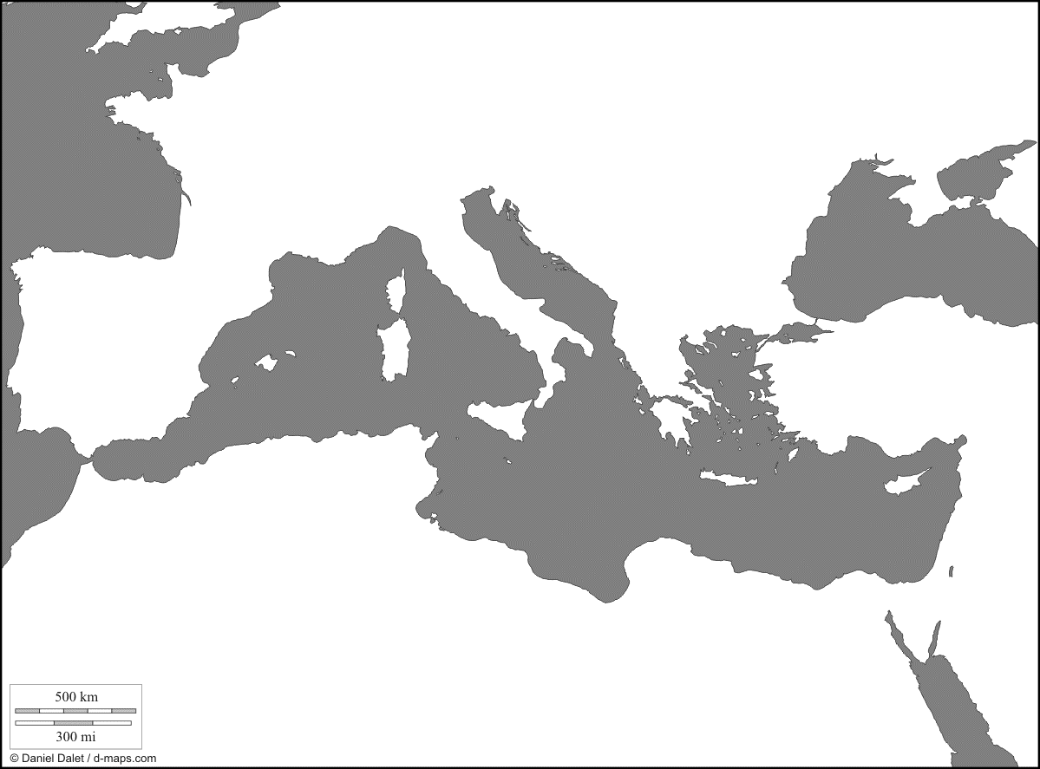

Vocabulary - Define each word using the glossary in the back of your textbook. To identify the people, you will need to look in the chapters or in the index for the specific page numbers.
- Abraham
- Covenant
- David
- Exodus
- Hatshepsut
- Hieroglyphics
- Menes (Narmer)
- Monotheism
- Moses
- Papyrus
- Pharaoh
- Phoenician Alphabet
- Polytheism
- Pyramids
- Rosetta Stone
- Saul
- Torah
- Twelve Tribes of Israel
Study Questions – Use your class notes to answer the following questions.
- Where was the ancient Egyptian civilization located?

- How did the Nile floods benefit the Egyptians?

- Why were the pyramids built?

- Describe the process of mummification.

- What group of foreigners invaded and ruled the Egyptians during the Middle Kingdom?

- Who was the 1st successful female pharaoh of Egypt?

- What pharaoh wanted to change the Egyptians’ polytheistic faith into a monotheistic faith?

- What was the Egyptian written language called? What did they use to write on?

- Why was the Rosetta Stone so important to historians?

- Describe the Egyptian religion.

- The Phoenicians settled in Canaan—basically a desert. What did the Phoenicians do to survive? What wood did they use to construct their ships?

- What makes the Phoenician alphabet so special? Who could read and write in Phoenicia?

- Phoenicia also created colonies. What was the name of the colony that Phoenicia created in Northern Africa? Why is it better to colonize than invade?

- What is the Hebrew word for God?

- The idea of monotheism led to three very important religions. What are the three religions that developed out of the Hebrew belief in monotheism?

- Who is considered the father of all the Hebrews?

- How many Israelite tribes existed?

- Describe the Hebrew Exodus.

- What Israelite king created a capital at Jerusalem? How did he become king?

- Why did King Solomon have so many wives?

- After the death of King Solomon, the Israelites split up again, this time into 2 kingdoms. What were the names of the 2 separate kingdoms?

- What was the Babylonian Exile and the Diaspora?

- What are the 5 books of the Torah?

- Who gave the Phoenicians their name? What does it mean?

- How did the Phoenician alphabet and the Lydian money system spread throughout the ancient world?

Discussion Questions – Answer the following in essay format. You should have an introduction, body, and conclusion.
- What are the various theories behind how King Tutankhamen died? How are we able to get this information?

- Describe the history of the Hebrews.

