Early Man & Mesopotamia Study Guide
Vocabulary - Define each word using the glossary in the back of your textbook. To identify the people, you will need to look in the chapters or in the index for the specific page numbers.
- Agriculture
- Artifacts
- Artisans
- Civilization
- Prehistory
- Culture
- Cuneiform
- Archaeology
- Domestication
- Scribe
- Pictogram
- Cultural Diffusion
- Irrigation
- Polytheistic
- Nomads
- Ziggurats
Study Questions – Use your class notes to answer the following questions.
- Why do we study history?

- Explain BC/AD and BCE/CE.

- What is a primary source? Give examples.

- What is a secondary source? Give examples.

- How did physical geography influence the lives of early humans?

- What were the characteristics of hunter-gatherer societies?

- What have archaeologists learned about Neanderthals and Cro-Magnons?

- How did the beginning of agriculture and the domestication of animals promote the rise of settled communities?

- How does archaeology provide knowledge of early human life and its changes?

- What are the two early cities in the Fertile Crescent being studied by archaeologists?

- What is the Neolithic settlement currently being excavated archaeologists in Anatolia?

- Why did ancient civilizations develop in river valleys?

- Write whether each characteristic describe something from the Old Stone Age or the New Stone Age.
  - ___________________________ Developed weaving skills.
  - ___________________________ Invented the first tools
  - ___________________________ Discovered fire.
  - ___________________________ Created cave art.
  - ___________________________ Settled communities.
  - ___________________________ Also called the Neolithic Era.
  - ___________________________ Lived in clans.
  - ___________________________ Made pottery.
  - ___________________________ Used advanced tools.
  - ___________________________ Developed oral language.
  - ___________________________ Domesticated animals.
  - ___________________________ Developed agriculture.
  - ___________________________ Also called the Paleolithic Era.
  - ___________________________ People migrated in search of food, water, and shelter.
  - ___________________________ Used plows and irrigation.
  - ___________________________ Invented the wheel.
  - ___________________________ Beginning of calendars and religion.
  - ___________________________ Creating bricks and metal work.
  - ___________________________ Stonehenge was built during this time period.
  - ___________________________ This era ended when people started using metal or bronze around 5,000 years ago.

- What type of government did most early civilizations have?

- What religious traditions developed in ancient civilizations?

- What were the earliest written symbols?

- What was the first written language called? What civilization created it?

- What was the Epic of Gilgamesh?

- Why was Hammurabi so important?

- What were some of the Sumerians’ inventions?

- The Assyrians were the first to use what warfare techniques?

- How did the Assyrians treat people they had conquered?

- What ancient wonder of the world was in the city of Babylon?

- The Persian Empire was located in what modern day country?

- Describe the Persian religion.

- How did Persia govern its empire?
- How did the Persians treat those they had conquered?

Discussion Question – Answer the following in essay format. You should have an introduction, body, and conclusion.
- What was the Neolithic Revolution? Why is it important? Describe the new inventions and discoveries of the Neolithic Era.

Maps – Use the textbook to complete the following maps.
- Label Africa on the map below. Describe what is illustrated by this map.
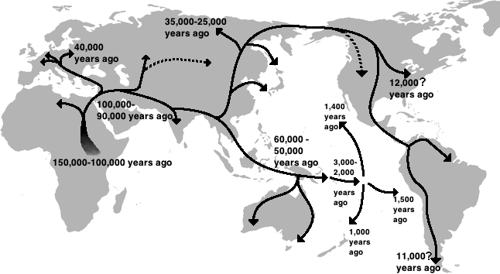

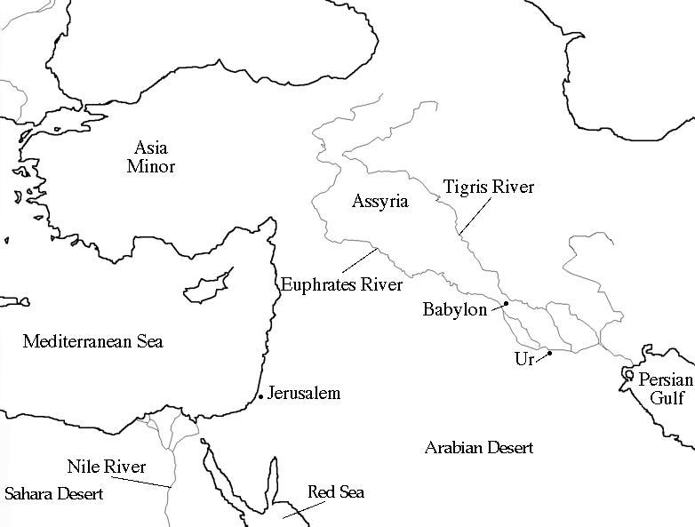
- Color or shade the area of Mesopotamia on the map below.

